Shipping History Process Guide

Do not delete gray highlight areas. Use orange button to edit title, headers, footers, etc.

Process / Application: | All business streams
Process Tasks: | N/A
Comments / Summary: | Purpose of this process is to allow team members to search for and find historical information regarding Trane product
User Role / Function: | North American Region Team Members
Organization / Contact: | HVAC North America - Equipment Fulfillment / HVACR NA Business Operations Support, Equipment Fulfillment, 1-800-444-6224, Option 3 /2

Contents | (Click or Ctrl+Click on Contents item to go to that section.)

1
.0 Business Overview 1
2.0 Serial Number Explanation 1
3.0 Tips and Tricks: Additional Manufacturing Facility Information 1
4.0 Navigation Process Steps 2
5.0 Recorded Demonstration 5

Business Overview
Using the Shipping History feature in WorkSight (Navigate to the Jobs List page at https://salestools.trane.com) allows any team member to search for and find historical information regarding Large Commercial Applied and Unitary Trane product that has been shipped through our order management systems (FOE/Kodiak).

Serial Number Explanation
Large Commercial Applied and Unitary serial numbers have a distinct sequential reference as shown in reference chart. As noted, older equipment (pre-1990) does not always follow current rules.

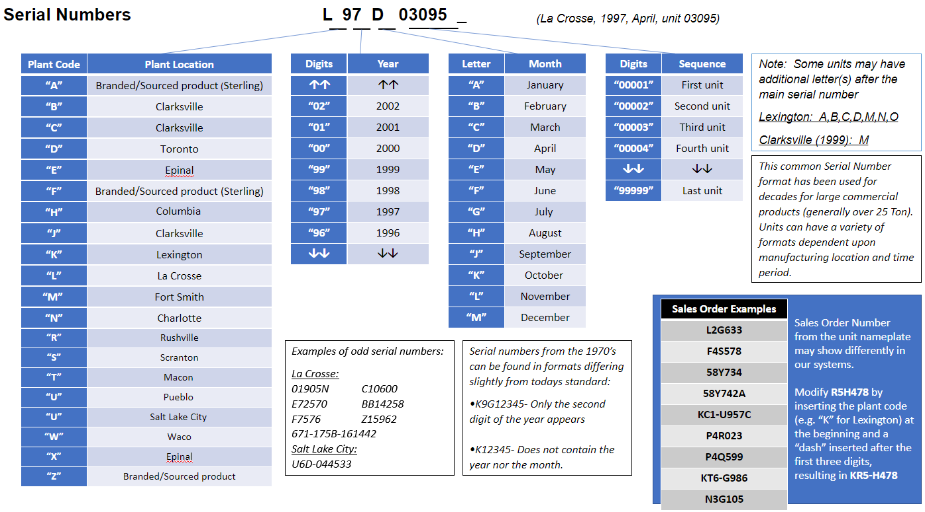

Tips and Tricks: Additional Manufacturing Facility Information
This information will provide tips and tricks to better understand the results of searching Shipping History.

Plant Code | Manufacturing Facility | Tips and Tricks to Locate | Potentially Missing Data | Further Contacts
A | Sterling  (branded/sourced product) |  | 99% of information available is Bill of Lading only | For further information refer to E-Library or email techservice@sterlinghvac.com
B | Clarksville | Normally from 1960 - 1980's. After "B", Clarksville moved to "J".
C | Clarksville | Serial number from Clarksville that is from 1999 will have an additional "M” at the end of the serial number in our systems (not necessarily on nameplate)  C99XXXXXX add “M”  example C99J17409M | Units prior to 1999 generally not available
D | Toronto |  | Generally records are not available
E, X | Epinal | Note: Important to ensure these are true Epinal units, some old serial numbers from other locations have started with E.  Epinal serial numbers look like:  EKN0214  EKN0215 |  | EMEA Technical Service,  Olivier Frey,  Olivier_frey@trane.com
F | Sterling  (branded/sourced product) |  | Generally records are not available. | For further information refer to E-Library or email techservice@sterlinghvac.com
H, T | Columbia | "H" has historically been used for Columbia  "T" is used for products relocated from Macon (starting 2019)
J | Clarksville |  | Pre-1998 (J93-J98) and some of 1999 (J99) not available, or only packing list available
K | Lexington | may need to add A,B,C,D,M,N,O to serial number  search K5D123456 as “K123456” or “123456” | Serial numbers such as K43101819D (non standard s/n) are light commercial (<25T), would not have records available.
L | La Crosse | Examples of odd serial number specific to La Crosse:  01905N, C10600  E72570, BB14258  F7576, Z15962  671-175B-161442 (try searching just 161442) | Rental Units Manufactured in La Crosse  -Serial or Sales Order Number may not be located for a La Crosse unit.  -Job Name will usually include the word "Rental"  -Plant Code may show "N" for Charlotte conversion unit | La Crosse Rental Units contact Trane Rental Services "tranerentalservices@trane.com"
M | Fort Smith | For 1999 and 2015 some serial numbers used a “C” prefix. Record may pull up with no data, need to contact support. |  | Send in request to Ship History email inbox at "gamshinfo@trane.com"  Indicate the request is specifically for custom air handler team and it will be routed
N | Charlotte | These are Conversion Units (R'newal) where the original serial number is retained and a new serial number is issued starting with "N".  Search for both serial numbers as records may exist for original unit and for the conversion.
R | Rushville | Many times, there are multiple units on one sales order. Search by serial number, then note the sales order number and search on that also. This may return all units associated with that sales order. | Records generally not available prior to 1994
S | Scranton |  | Older records prior to 1998 generally not available.
T | Macon | Macon plant (T) closed production moved to Columbia | Records from 1992-2000 (T92 - T00) are generally not available
U | Pueblo | Production moved from Salt Lake City "U" to Pueblo "U" in 1988 | Rental Units Manufactured in Pueblo  -Serial or Sales Order Number may not be located for a Pueblo unit.  -Job Name will usually include the word "Rental"  -Plant Code may show "N" for Charlotte conversion unit | Pueblo Units (email all)  Jo Newbauer Jo.newbauer@trane.com  Nicole Sanchez nicole.sanchez@trane.com  John LoPresti john.lopresti@trane.com  Pueblo Rental Units contact Trane Rental Services "tranerentalservices@trane.com"
U | Salt Lake City | If Serial number is prior to 1988 with “U” prefix, it is from Salt Lake City plant location  Salt Lake City example: U6D-044533
W | Waco | Many times, there are multiple units on one sales order. Search by serial number, then note the sales order number and search on that also. This may return all units associated with that sales order.
Z | (branded or sourced product)

Navigation Process Steps
TASKS / STEPS | DESCRIPTION / INSTRUCTIONS
Navigate to the Project page from the Jobs List at https://salestools.trane.com | 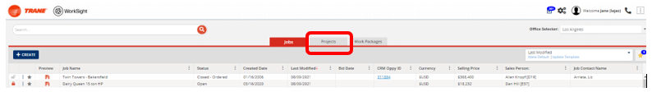
Choose Shipping History toggle on far right side of page | 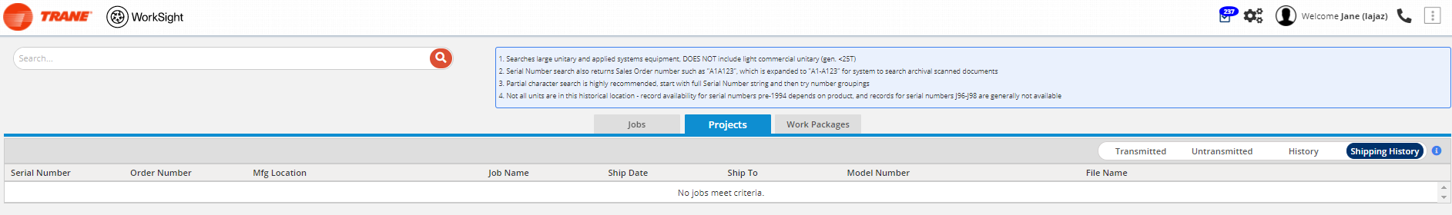
Use Search section to enter Serial Number OR Sales Order Number (ALL CAPS), then click the search icon (or hit enter) | 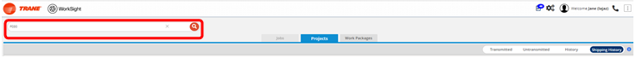
Search results will search both Serial Number and Order Number columns.  TIP: If full serial / order number do not provide results as expected, enter partial data chains.  Exact match is required for systems generated data (post 1994, partial search works for scanned records (pre 1994). | Serial number L06L05354 was used to search in ALL CAPS which provide results that matched the specific serial number. If we searched partial informaiton that would possibly provide multiple results to choose from.  Note: The search will return results for the sales order in two formats: A1A123 and A1-A123. Sales orders have been re-used over the years across multiple locations, so the search shows all potential results that it find.  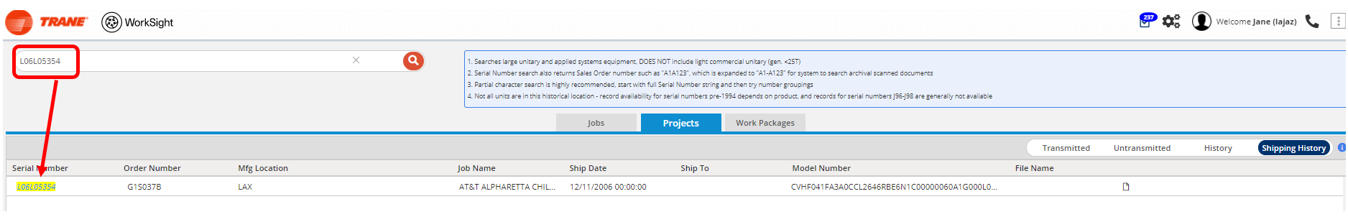
Choose the document icon to download the document.  A message will be displayed indicating you will receive a notification on the request status. | 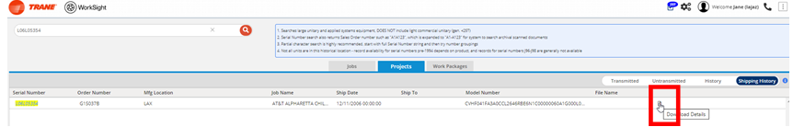  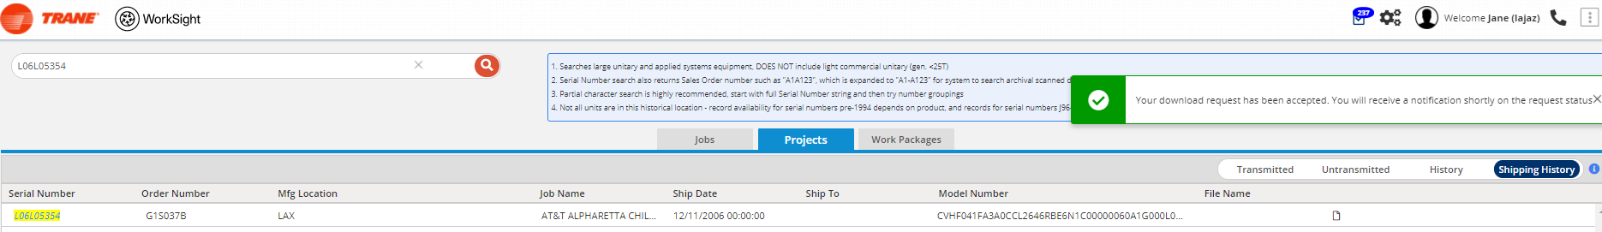
Open the Task List and Notifications.  Click on the notification link to open the file  The file will be in PDF form for your reference. Note that the PDF file may have multiple pages to review before it provides the specific details needed.  TIP: Scanned records (pre 1994) will download automatically. | 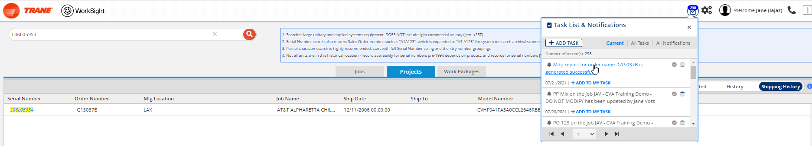  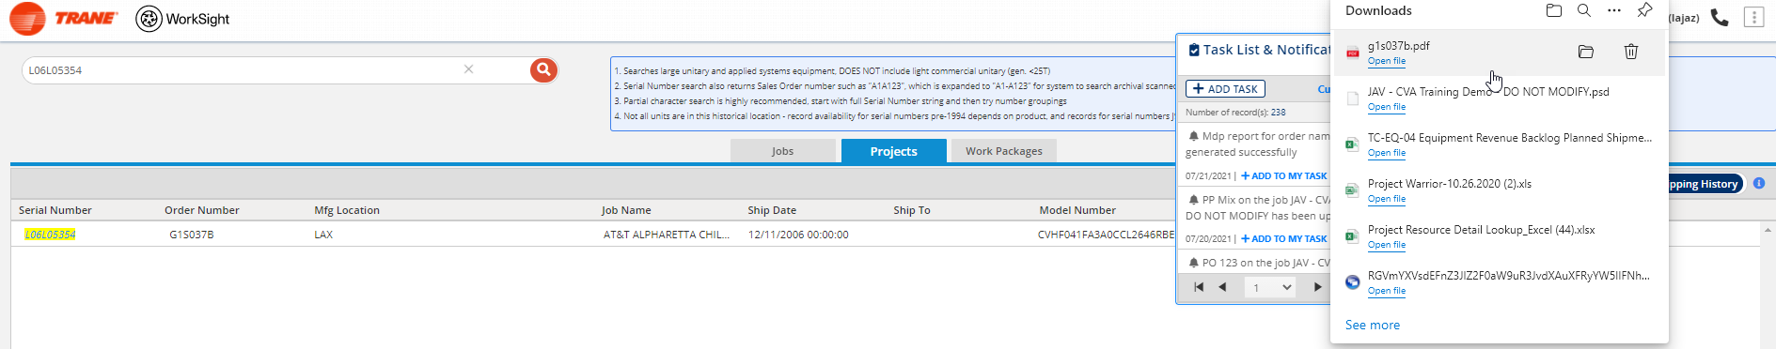  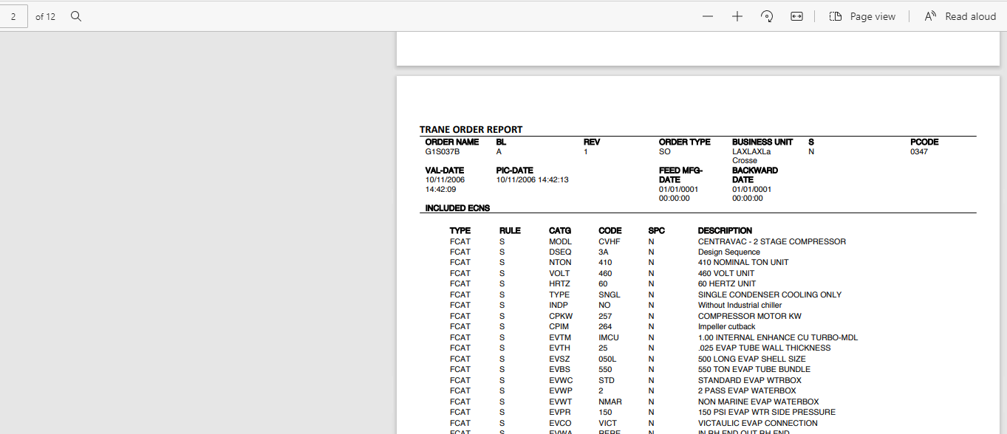

Recorded Demonstration
Demonstration Recording | https://web.microsoftstream.com/video/3946123b-f49a-4b5d-88de-81f2b2d75b71

