Actuator Set Up
Items needed:  Actuator Template, Actuator Crank Arm, Guide Pin, Driver, #15 torx bit, hex bit, 7/16 combination wrench | 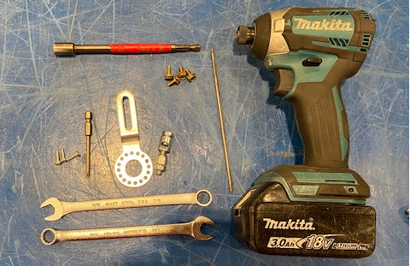
Set actuator template on the actuator. Flange to the right, actuator pins on the left. | 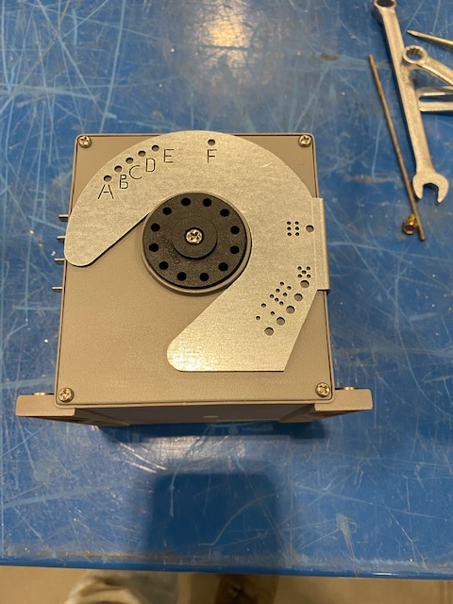

Set the crank on the actuator and use hole D to position the crank. You can use a pin, or by sight | 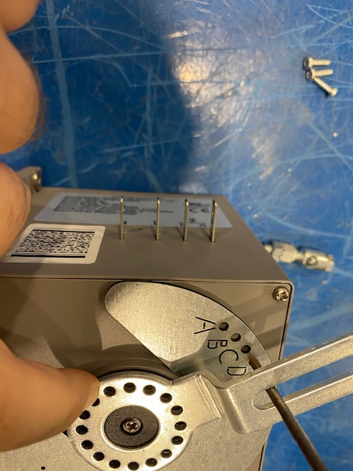
Line crank up to nearest set of holes. Tighten down with 3 torx screws in the holes farthest from the crank arm.  If the rod lock was moved…  Insert rod lock 2 inches away from the center of the actuator and tighten down. | 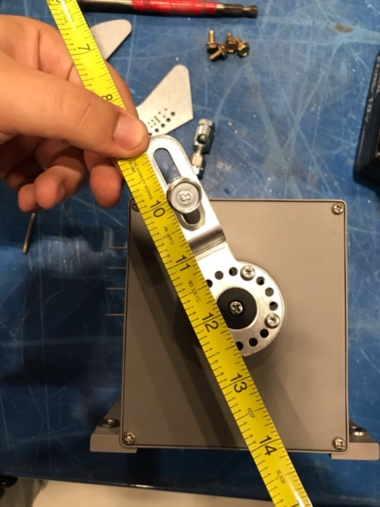
Fasten the bracket to the base of the actuator with 4 brass machine screws. Bolt heads on the bottom. | 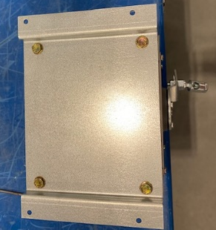  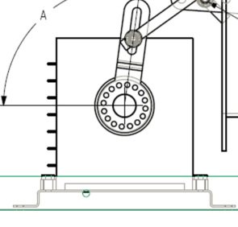
Fasten the actuator (crank arm to you) to the base using 4 sheet metal screws (grayish/silver looking)  The unit should be in the orientation seen (except the dampers have 2 blades instead of 1) | 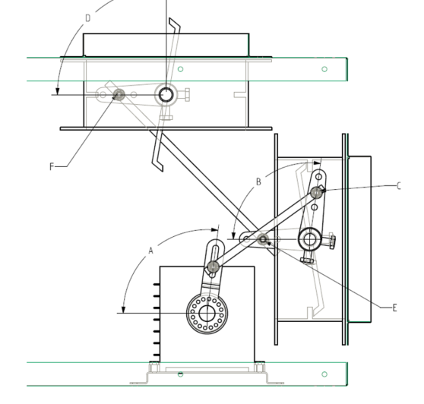
Fully close the Return Air damper.  Slide the RH Template onto the return air damper. The “TOP” label should be at 9 o’clock with respect to the shaft. Slide the crank arm on after. Align the farthest hole to the template hole labeled 3.  Tighten down crank and remove template. | 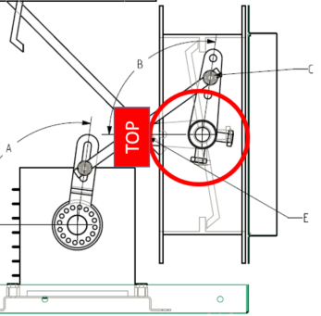
Go to the opposite side of the Actuator. Ensure the Fresh Air damper is fully open  Attach a crank to both dampers at 3 o’clock with respect to the shaft.  Thread the rods in and tighten. The longer rod connects the actuator to the return air damper. The shorter rod connects the dampers together.  Attach wire harness to pins top down (Yellow, Blue, Pink, Brown) | 