Product: Terminal Products

Subject: ZN Controllers – Rover Tool

Details: Troubleshooting tips/ Information

ZN010 requires a communication KEY- Part number KEY0482

Fan speed resistance values:

Setpoint resistance values:

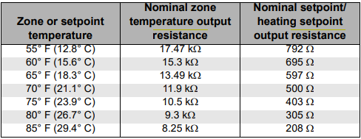

Resistance curves for all 10K Thermistors.

Manual Output test:

ZN010 and ZN510

ZN520

