Product: All Terminal Products

Subject: Adjusting Fan speed

Details:

RPM adjustments can be made on all terminal products with the ECM (blue) board.

Every IOM for terminal products has a section called (ECM overview and set-up) review that section to understand how to navigate the board.

NOTE: There are 44 different settings in the ECM board however only a few actually change the RPM’s.

***E1M1 Setting DX or Electric heat***

* DX or Electric heat equipped units lock the RPM settings. Those are E1M1 and E2M1. Units that have two motors there are E1 and E2M2 settings.

Turn off EHPT to make changes on these units however note that the RPM settings are set for a reason.

1. To not frost the coil.
2. To not overheat the electric heat elements.

Lower only after testing discharge air performance in DX and or electric heat modes.

***Analog or 24v speed settings***

Every unit comes with preprogrammed analog and binary settings for motor speeds

To adjust 24v the first three settings are H-M-L

HI1 -MD1-LO1 – These are for units equipped with 1 motor.

Ahm1 and Alm1 are for analog control of motor 1.

Motor starts at .5 VDC for ALM1 and ramps linear to the AHM1 RPM setting at 10VDC.

***Every unit comes with a sticker with the serial number and some parameters that can be changed- See Example from the IOM***

***NOTE: Do not change the other settings unless you talk with technical support about the impacts to performance***

***Any changes requires you to hold down the set button***

***In other words the SET button is a SAVE button***

***Defined buttons***

***Viewing motor settings***

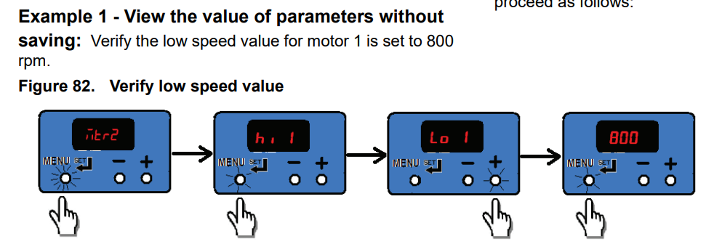

***Changing Fan speeds***

***Refer to the IOM for more information in the ECM overview and set-up section***