**Creating a TrendView**

1. Open Tracer TU.
2. **Connect** to the UC800 with Tracer TU, or choose to **Work Offline** if unable to connect to chiller UC800.

If working offline it will be necessary to have saved the Data logs or have Retrieved the UC800 Data Recorder files beforehand. Reference Knowledge Center **wave136201** for instructions on Retrieving the UC800 Data Recorder Files.

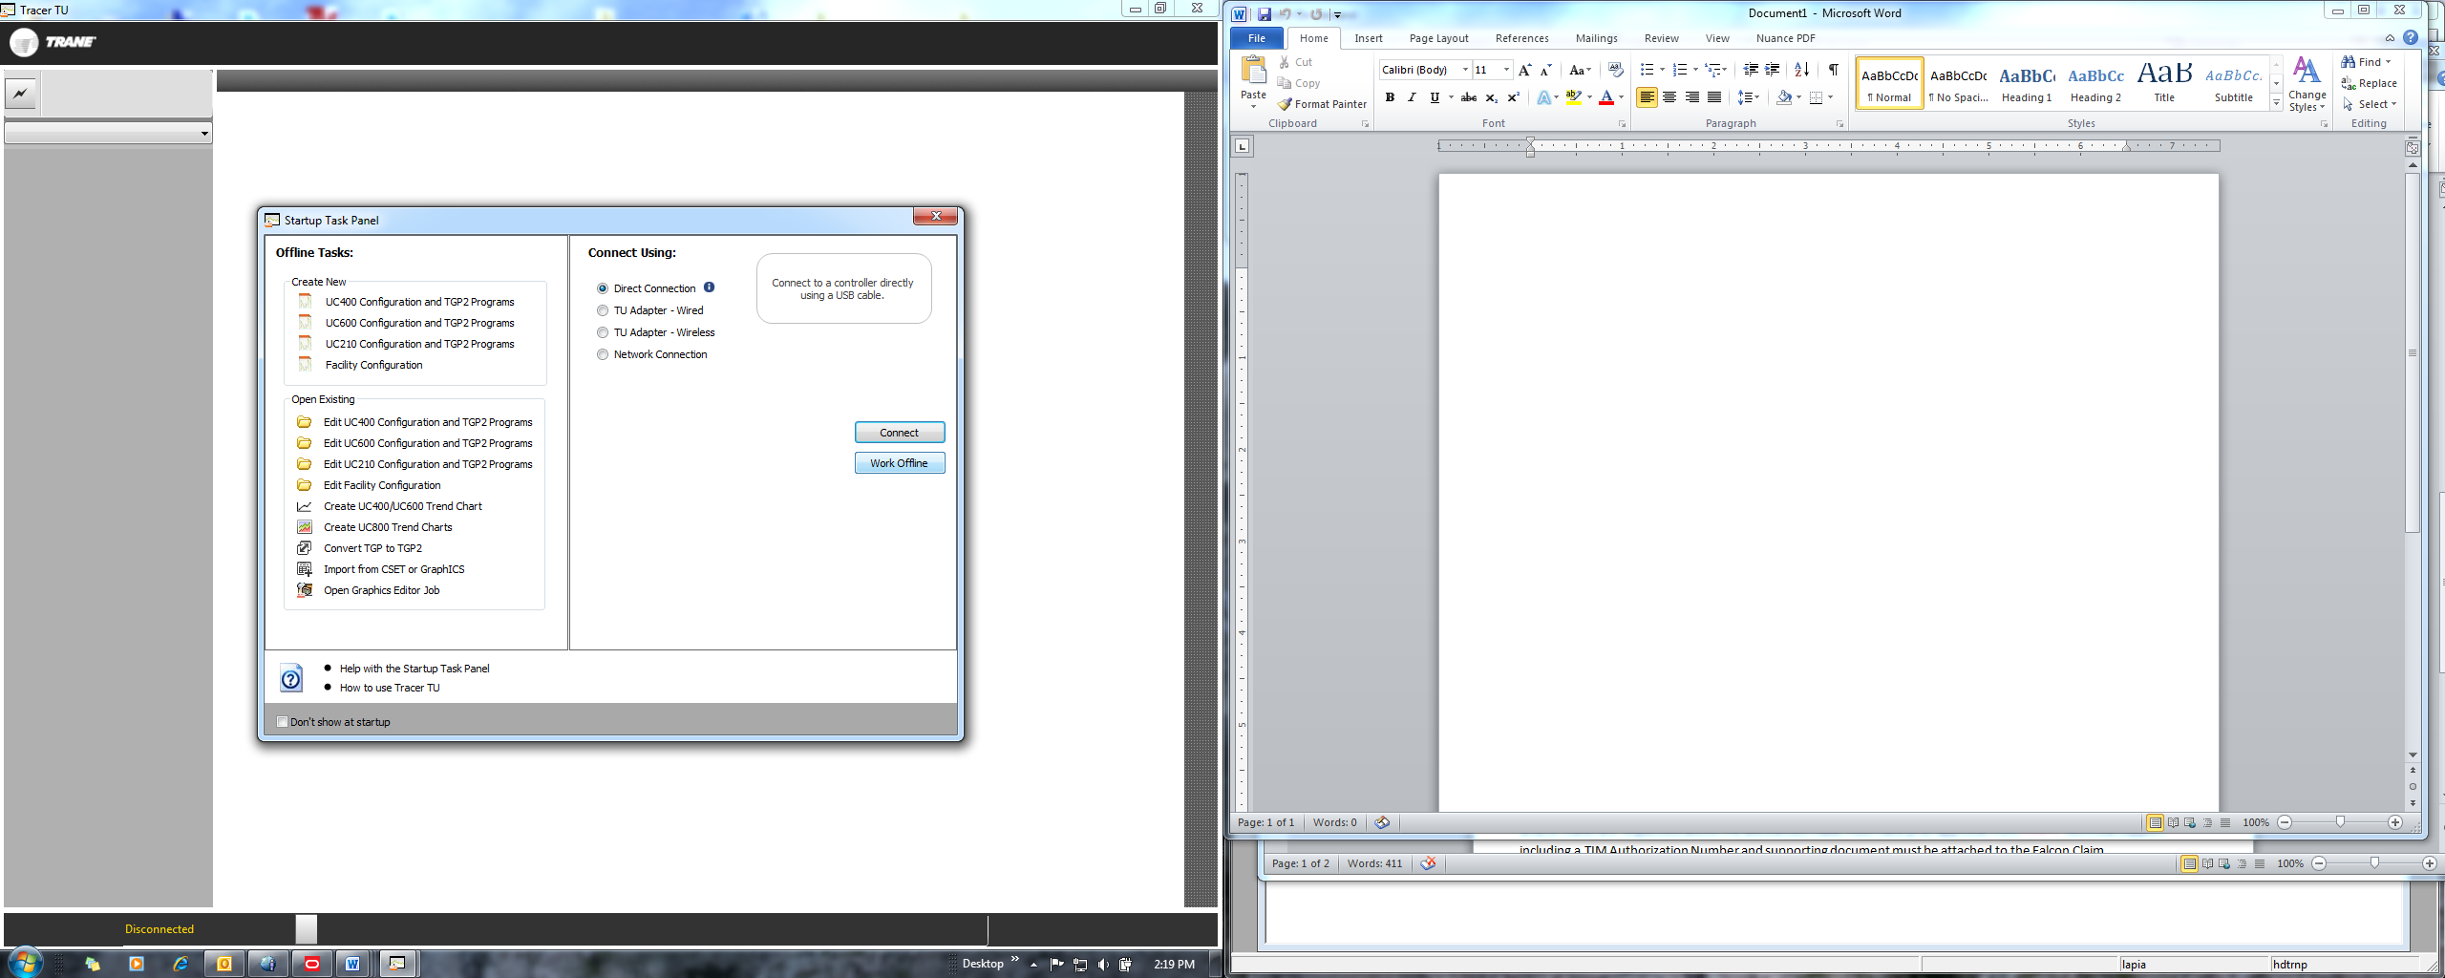

1. Select the **TrendView** heading, then **Launch TrendView**.

**Working Offline:**

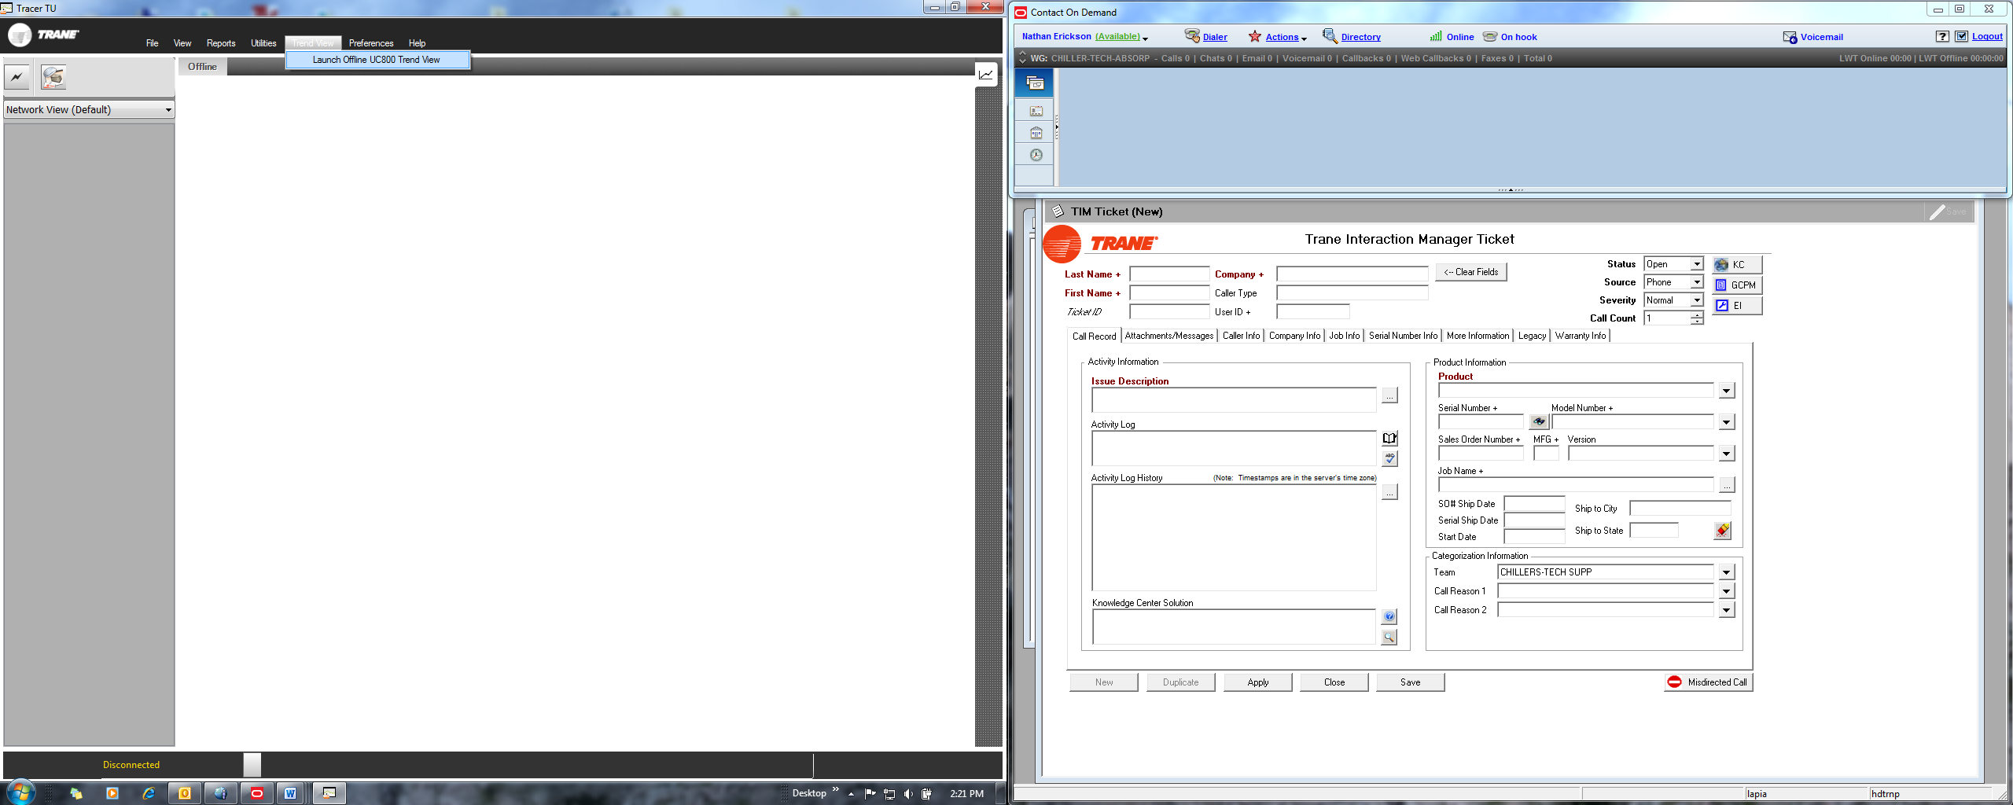

Proceed to step 6.

**Connected to UC800:**

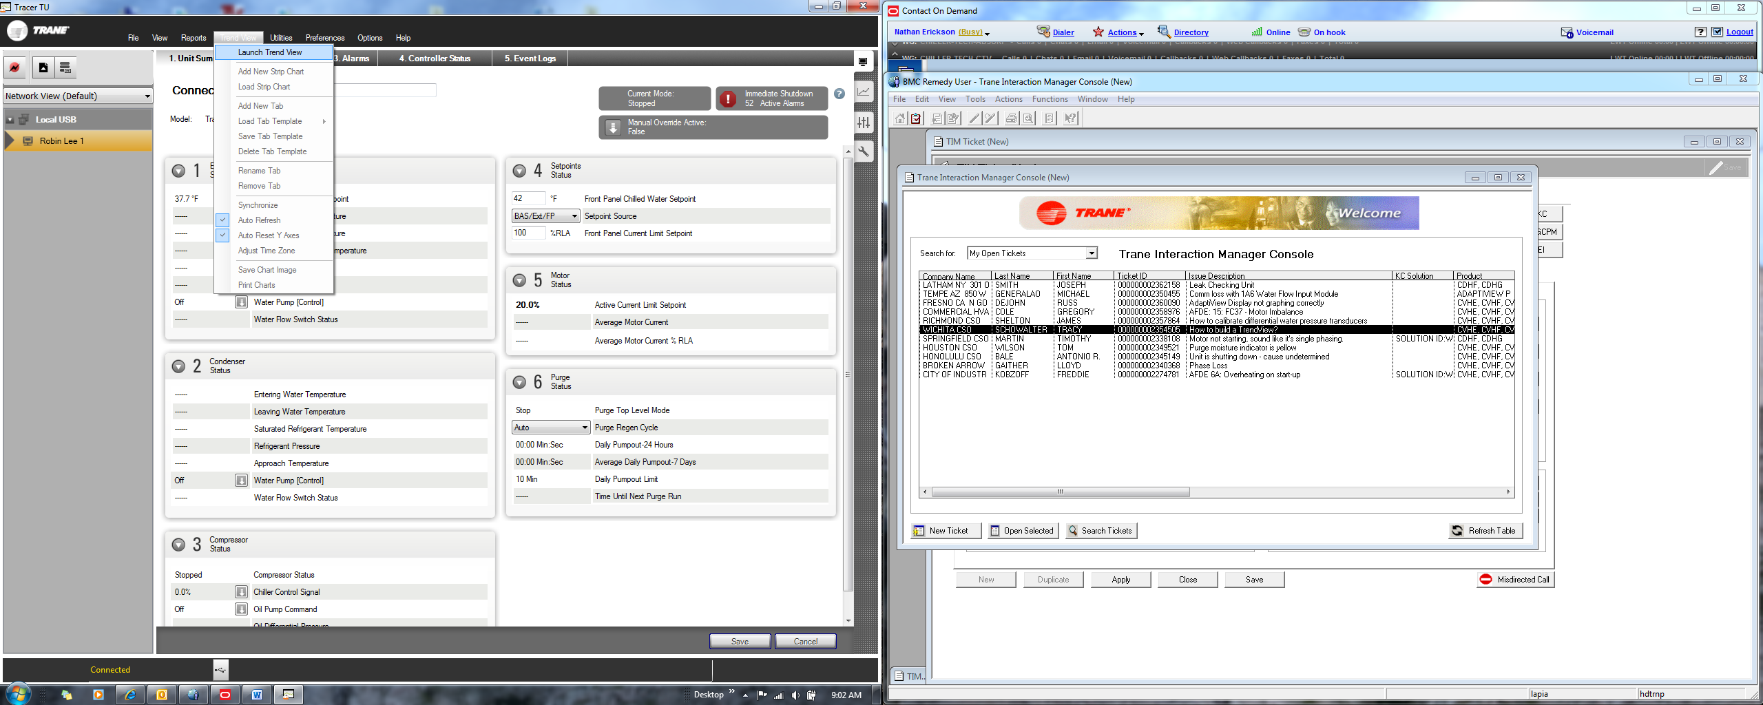

Proceed to step 4.

1. If Tracer TU is connected to a UC800, a series of graphs will be generated automatically from the data within contained within the Data Log files. This data is recorded beginning once the Tracer TU connects up to the UC800. Each graph can be selected and additional plots added to each graph, or the graph can be removed if desired. Additional charts can also be added by accessing the **TrendView** heading.

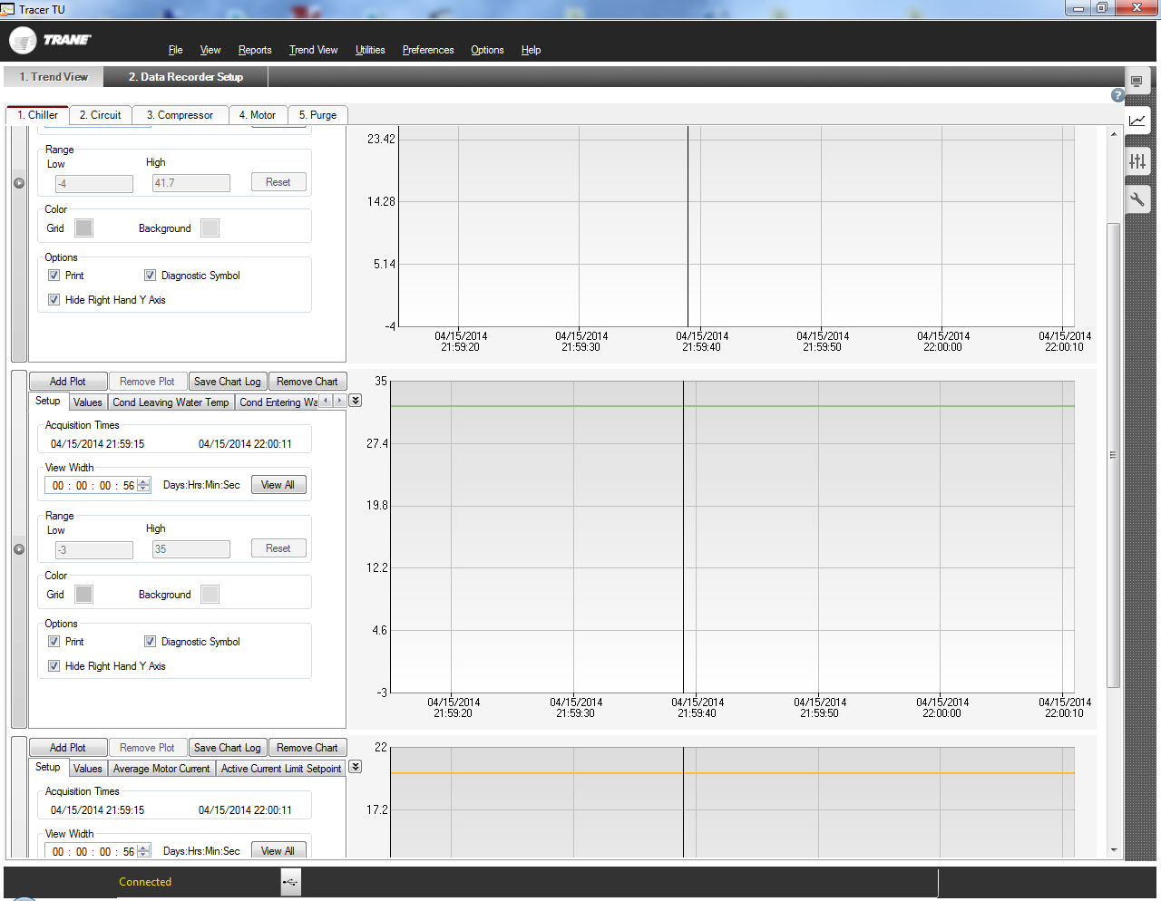

1. Creating New Strip Chart
2. **Add**ing a **New Strip Chart** will generate a plot using data from the Data Log file.

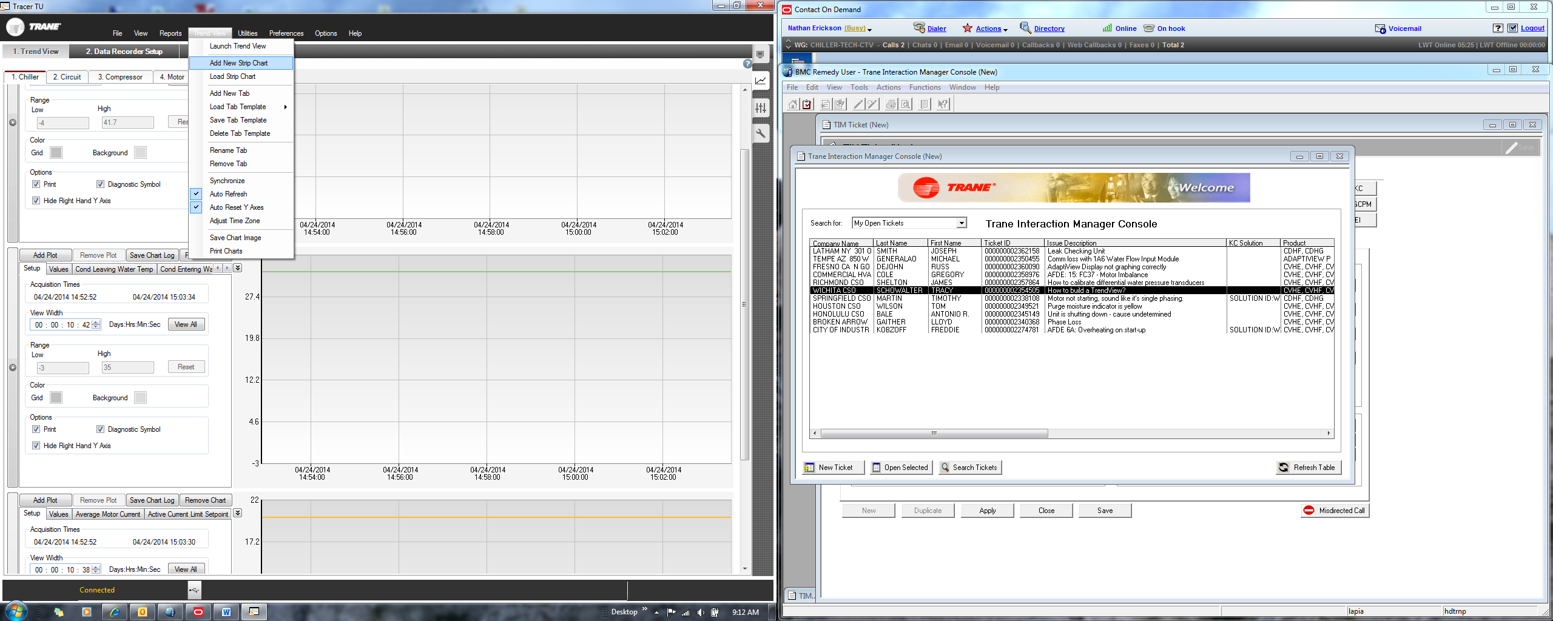 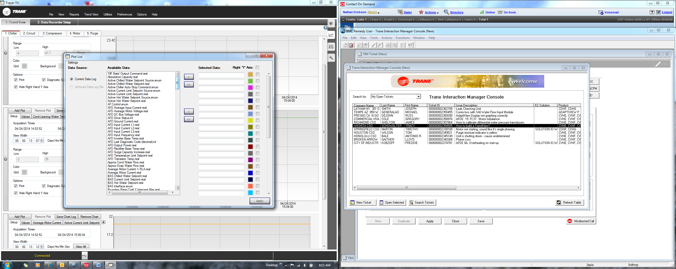

1. **Load Strip Chart** will generate a TrendView from the Archived Data Files (i.e. Data Recorder Files), which will allow you to select which file you choose to generate the TrendView from.

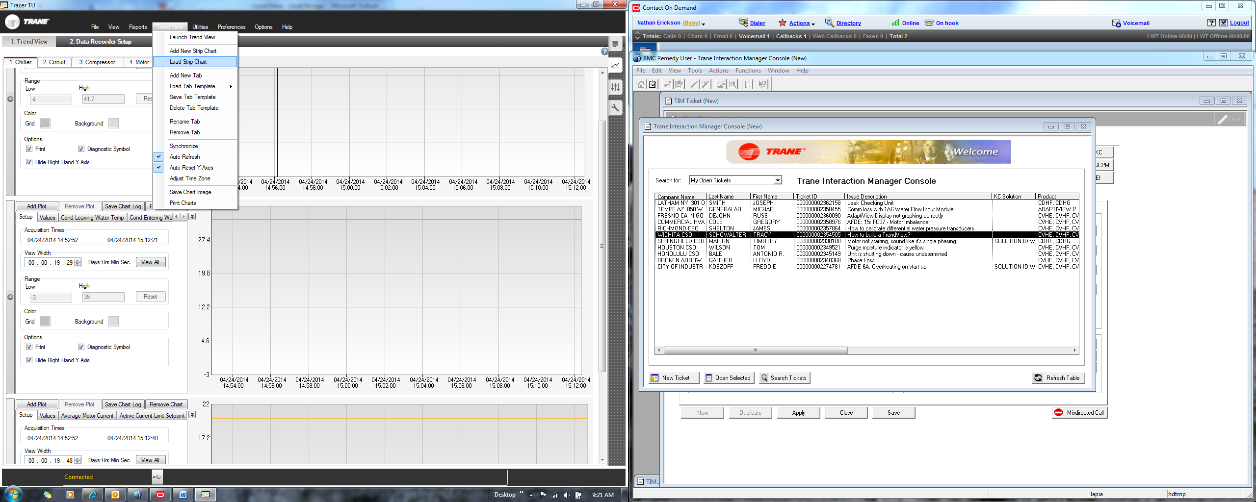

1. Once **Launch TrendView** is selected (if working offline) or **Load Strip Chart** (if connected to UC800), it will go to the **My Documents** >> **Tracer TU** >> **Data Logs** >> **UC800** folder by default. Select the file you want to generate a TrendView with. The file name has information that includes the Job Name, Chiller Name, Serial Number, file type (e.g. Default, Data Recorder, Custom name, etc.), as well as a time stamp for when the data was retrieved (e.g. 2014-04-15-14-54-31 = YYYY-MM-DD-hh-mm-ss).

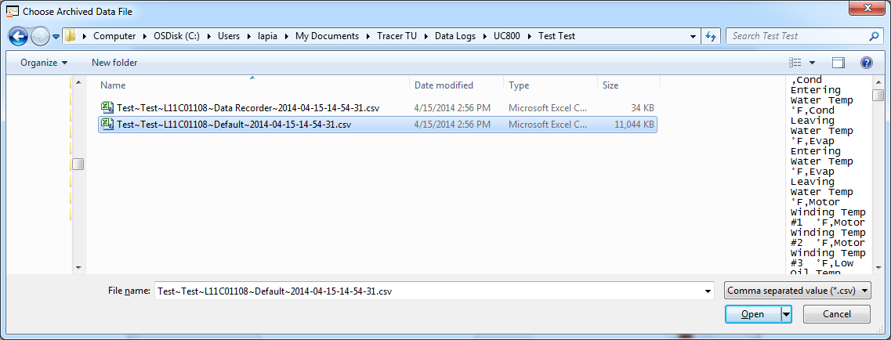

1. Once the file is selected the following **Plot List** will appear. Select each **Data Point** in the **Available Data** list that is desired and move it into the **Selected Data** list using the **Right Arrow** button.

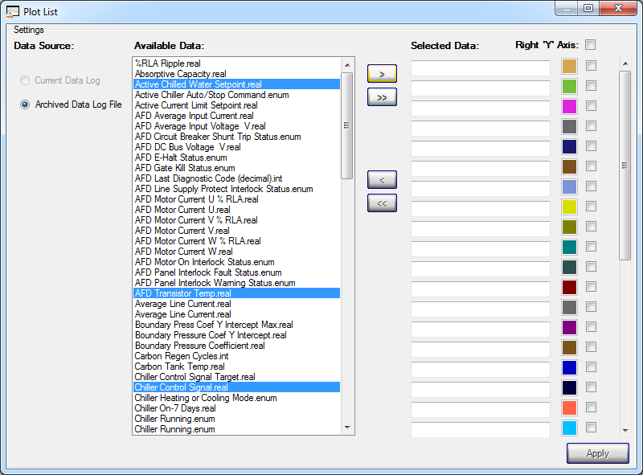

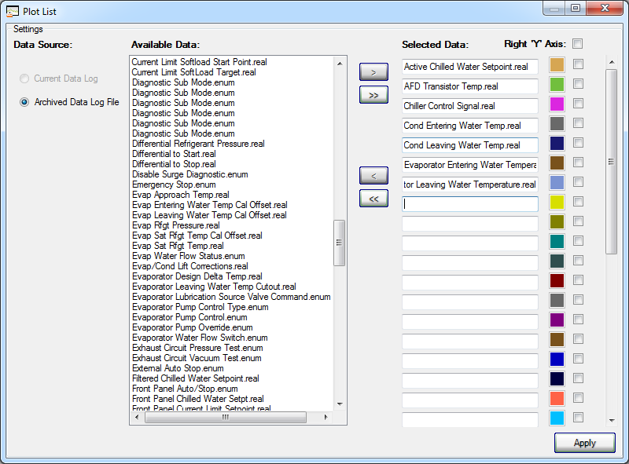

1. It may be helpful at this point to select colors you want to see for each data plot. This becomes helpful when looking at multiple data plots on TrendView. To do so, select on the color box on the Right Hand side of the data point and a window will pop up with additional colors to choose from. Choose the desired color and select **OK**.

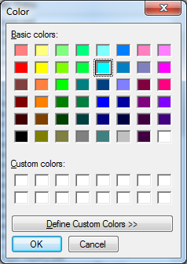

1. Once all the data points are selected from Available Data in the Plot List, select Apply and a TrendView will be generated

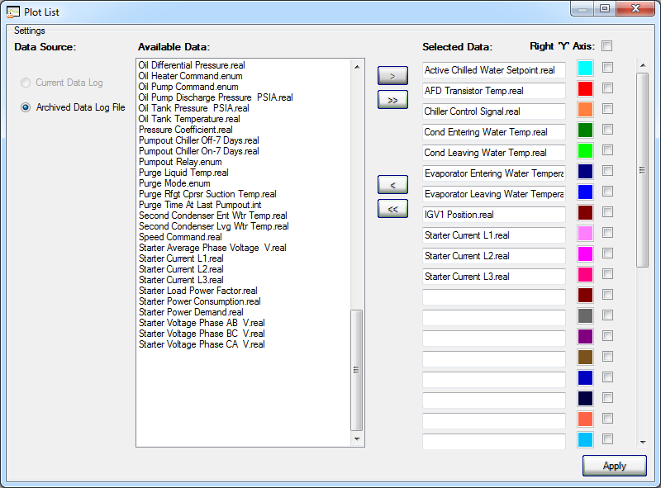

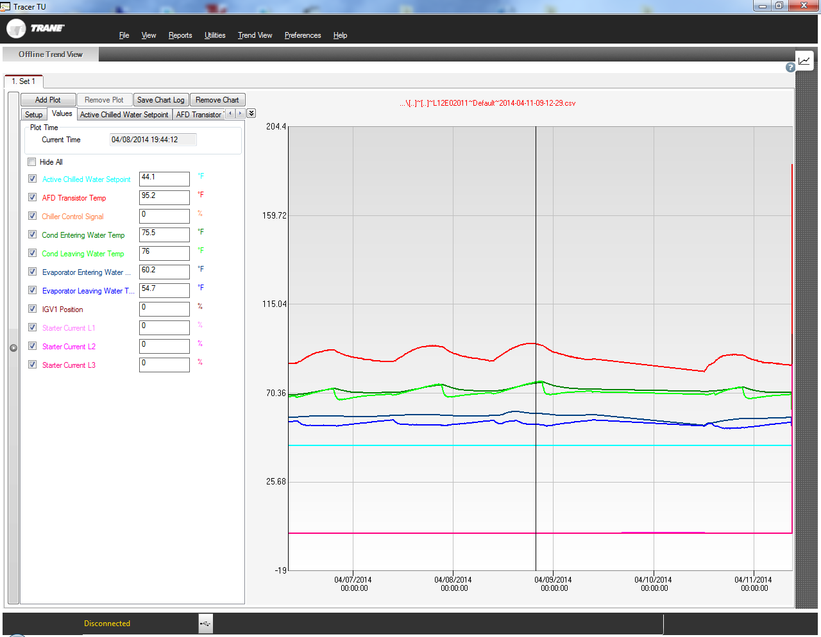

1. Since the Default and Data Recorder files record data over a longer period than the Data Log files (generally a few days’ worth,) much of the data can be congested and hard to view or interpret, so it may be helpful to zoom in on a particular area. To zoom in on an area, move the cursor over the TrendView to the beginning of a point in time that you wish to view, select and hold down the left mouse button, and then drag in the direction that you want to zoom in on. As you slide the cursor over (with mouse button help down) the selected area will become shaded in across the area that will be zoomed in upon. Letting go of the mouse button will initiate the zoom in.

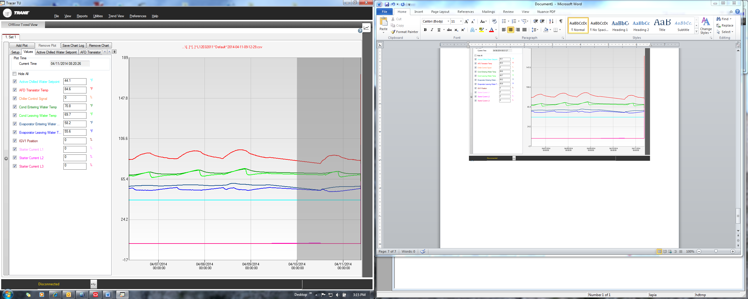

Repeat this as needed until the desired resolution of the data/timeframe is achieved.

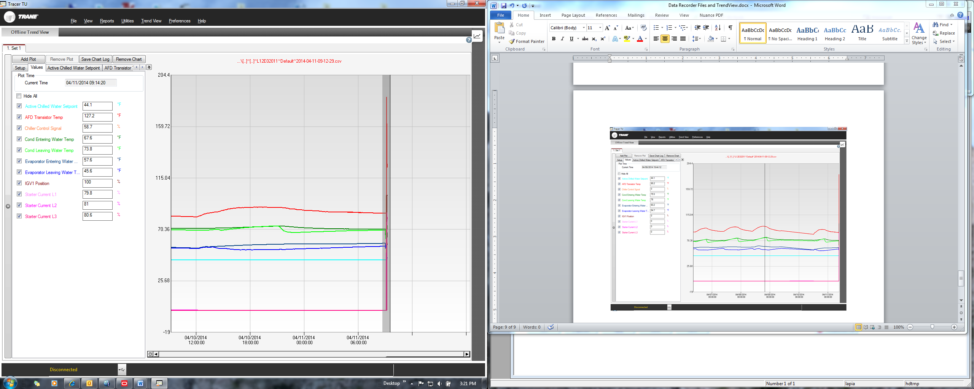

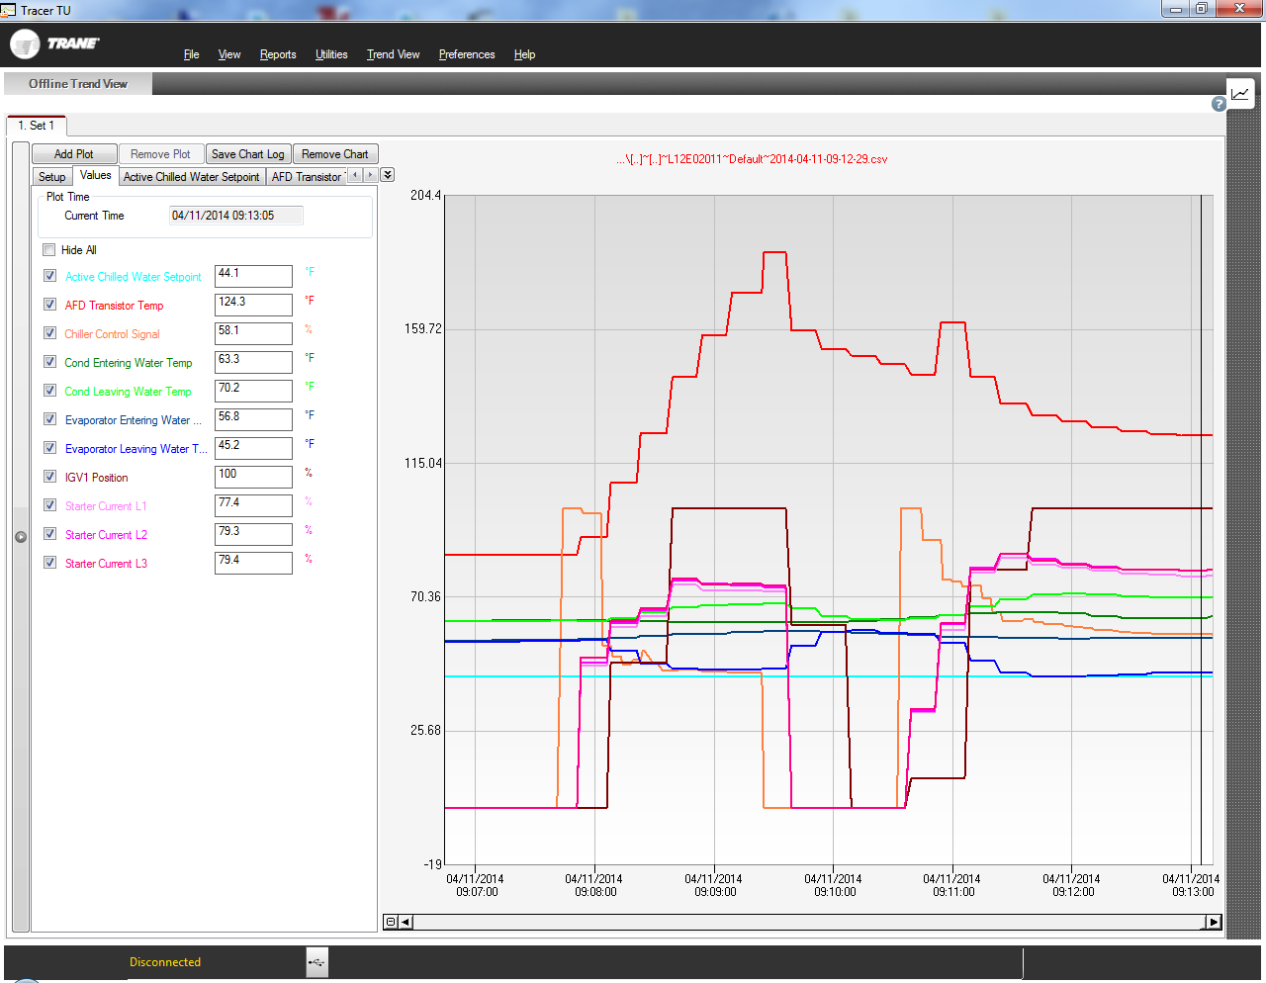

To zoom out, simply click on the 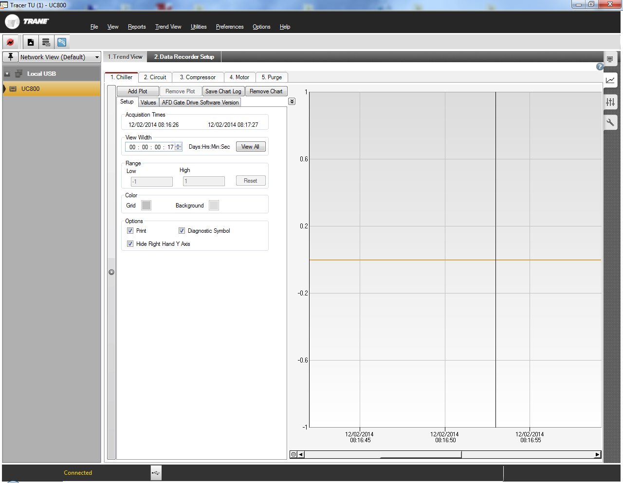 button located on the lower LH corner of the chart, to the left of the scroll bar. This will take you to the time frame that was last zoomed in on.

