**UC800 Data Files**

* Chiller Service Report
  + Chiller Status
  + Setpoints, feature settings, manual settings, level 4
  + Device List
  + Chiller Configuration: Starter/AFD parameters, Options, Options setup
  + Alarms and Events
    - Contains a time stamp of when an event occurs (needed for when viewing TrendView).
    - Records up to 100 Alarms/Events
* Event Log Report
  + Sequence of events
    - Shows running/operating modes (e.g. Starting/stopping, prelube, in surge mode, AFD re-optimizing, min/max capacity, current limit, evap limit, softloading, etc.)
    - Shows when diagnostic occurs (may not indicate what actual diagnostic was)
* Data Recorder files
  + Data Recorder
    - Only records data when compressor is Running (Recorder = Running).
    - Can be hard to interpret at time, especially if a lot of start/stops. TrendView looks like a sawtooth and can be hard to differentiate when the chiller’s actually running or not, or what may be occurring before or after a compressor starts.
    - Lower collection frequency (~5 sec.).
    - Downloaded automatically when retrieved via TU.
    - Records data over a 3-5 day time frame (typically). More or less depending on how dynamic the chiller operation is (e.g. one sitting idle will record data for a longer period vs on that has a lot of starts/stops/dynamic conditions, duplexes have shorter time frame due to higher number of data points, etc.).
  + Default
    - Records data whenever the UC800 is powered up.
    - Lower collection frequency (~5 sec.).
    - Downloaded automatically when retrieved via TU.
    - Records data over a 3-5 day time frame (typically). More or less depending on how dynamic the chiller operation is (e.g. one sitting idle will record data for a longer period vs on that has a lot of starts/stops/dynamic conditions, duplexes have shorter time frame due to higher number of data points, etc.). HDWA unis is only about 24-48 hours due to all the data points.
    - The Default file is large and needs to be compressed in order to send it via email.
      * TrendViewer will not recognize a zipped folder. Needs extracted first.
* Beginning with UC800 FW v11.05, the data points were “more standardized.” (i.e. the Data Recorder and Default DR file have a more common list of data points between them. Prior to v11.05, some data points would be in one file and not in the other (e.g. running modes were not in Default but in Data Recorder)). Only an issue if looking at data from a chiller of Dec. 2016 era that could have an older firmware version.
  + DataLog
    - “Session” data
      * Records data whenever TU is connected up to the UC800.
      * Records data directly to memory on the PC.
      * The option to save the DataLog occurs when closing out of TU; it asks to *Save the Data Log Files?.*
      * This file is most helpful when an event occurs, **but only if TU is connected to the UC800 at the time of the event**. It offers no help if an event occurs when TU is not connected to the UC800.
      * Since the data is being stored directly to your PC, there is much more memory available, therefore the DataLog contains a complete list of data points and the data point collection frequency is down to 1 sec.
  + Custom File
    - Technician needs to create a custom file with specific data points.
      * Can add Generic monitoring devices (e.g. pressure/temp transducer, analog inputs).
      * Can change sampling rate (down to 1 sec min.).
      * The more data points added or the lower the collection frequency, the smaller the time frame **all** the data recorder files will record since the UC800 only has so much memory available for recording data. So best to be selective about the data points needed in the custom file.
    - Up to three custom files can be generated with Data Points & collection frequency of choice; used for specific troubleshooting with points that aren’t in the standard list of data points on the Data Recorder of Default file (e.g. generic devices, etc.)
* Generally speaking, while we do monitor things like Input Currents, Motor Currents, Voltages, AFD Bus Voltage, etc., the UC800 is not an oscilloscope by any stretch. Especially Default & Data Recorder file that have a 5 sec. collection frequency. The DataLog is better at only 1 sec. collection frequency, but this is still a long time electrically. So depending on the issue, it won’t capture a true representation of the voltage/current waveforms, and therefore, is not the best tool for troubleshooting power related events. Although it may show a “partial” event, e.g. a voltage/current spike that occurs, but it likely won’t capture the true magnitude of an instantaneous event.
* The default directory for storing TU data is shown in the following Screen Print.
  + Data Recorder files (Default, Data Recorder, DataLog, Custom) are stored in the Data Log file.
  + Reports (Chiller Service Report, Running Chiller Service Report, Event Log Report) are stored in Reports folder.

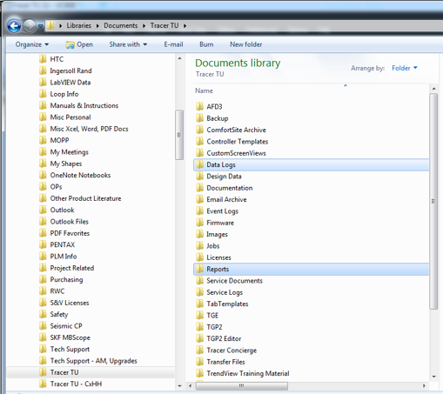

* Below is a caption of the four types of data recorder files: DataLog, Default, a Custom file “afd temp,” and a Data Recorder file.

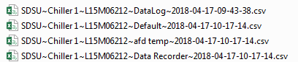

* + File name structure is as follows: **Job Name**~**Chiller Name**~**Serial Number**~**File Type**~ **Year-Month-Day-Hour-Min.-Sec.**
  + **.csv** stands for Comma Separated Value. Although it has the look and feel of an Excel file, it’s not. TrendView will not work with an Excel file.
    - Do not open a .csv file and modify it in any way. Saving it with any modification will cause the file to not work with the TrendViewer. If needed, copy the .csv file and save it elsewhere to view/modify the file.
  + When retrieving data recorder files:
    - By default, TU **always** retrieves the Data Recorder file, the Default File, and a Custom (ex: HDWA Custom in screen print) if one exists.

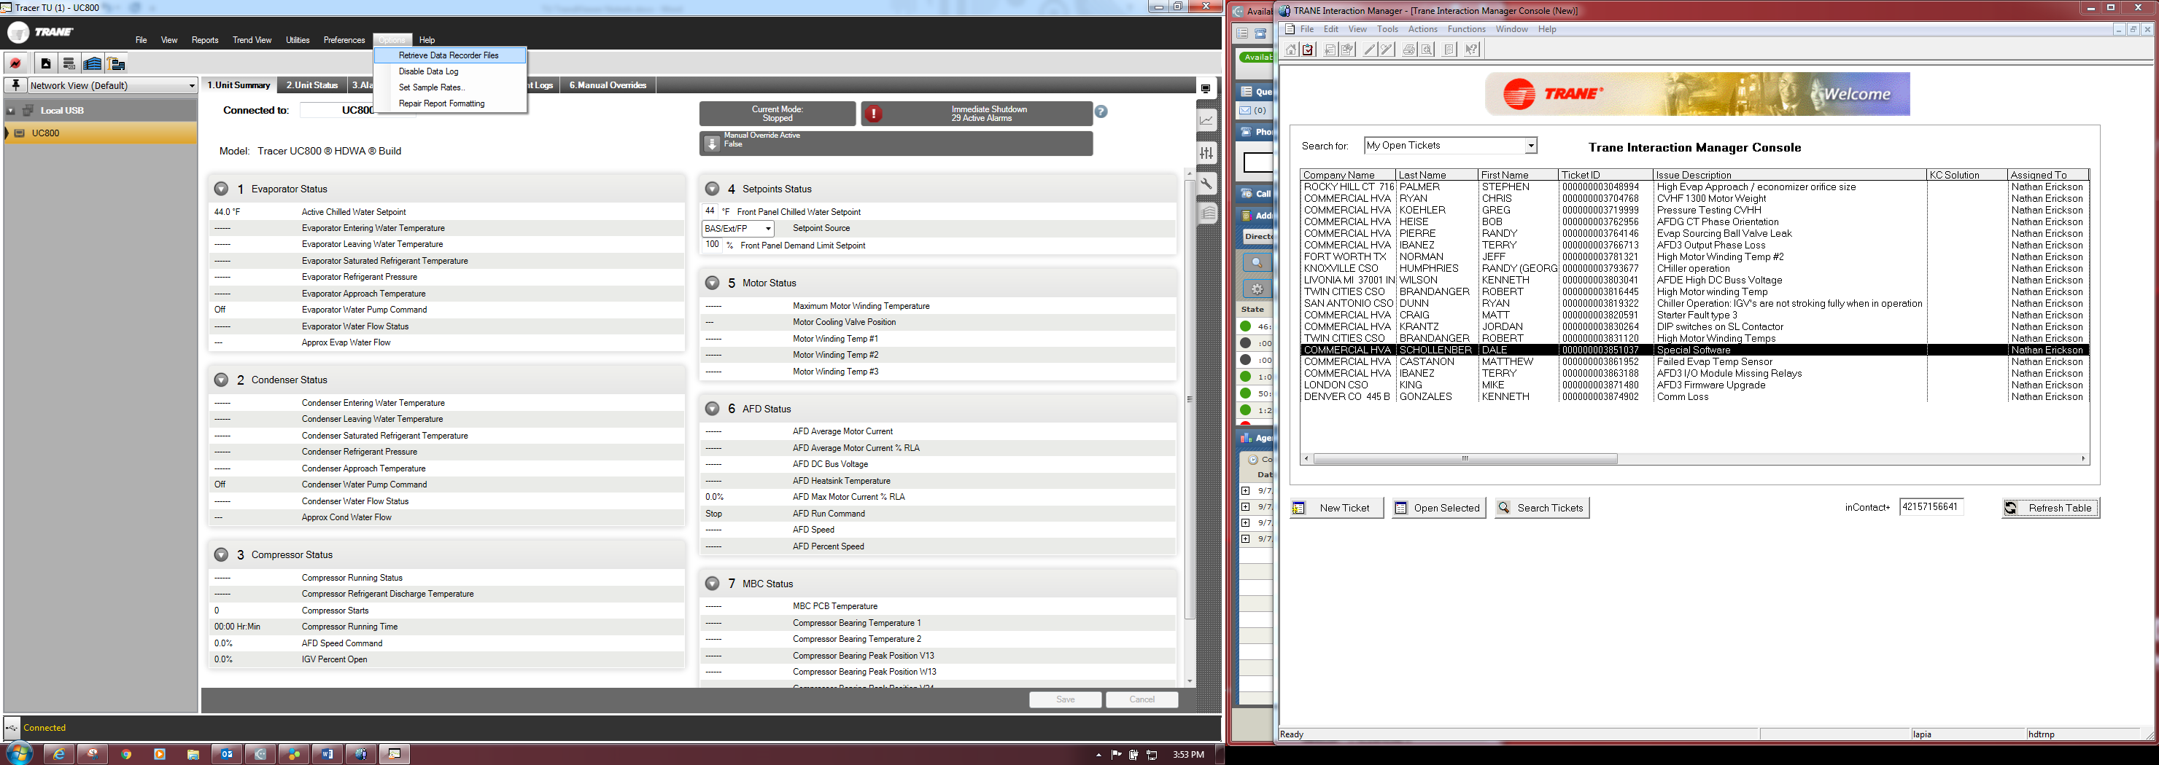

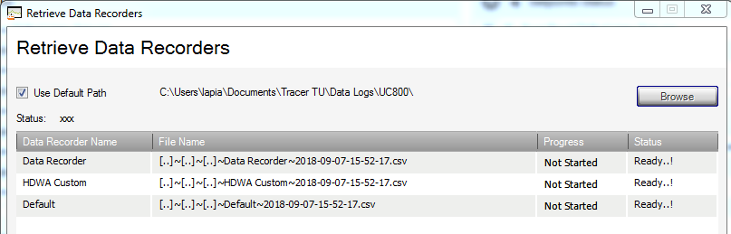

* + The option to save a DataLog occurs when Disconnecting from TU from the UC800, exiting out of TU, or if a connection was lost for some reason.

