RTAC Liquid Level Sensor Upgrade

There are 3 options of Liquid level sensors in the options setup menu. Make the appropriate selection based on the sensors installed on the unit. The one with the “Level Sensor with Integrated Electronics” in the description needs to be selected if you have the 56MM sensor.

In some cases the liquid level sensors must be upgraded to be used in Adaptiview. First try binding the way they are. If they bind, no further action is required. If they will not bind, they will show up as extra LLIDs. Unbind these and rebind. During rebinding update the LLID firmware when prompted. Do these one at a time. May have to go through the unbind/rebind process a second time after upgrading. Follow the attached screenshots and instructions if necessary.

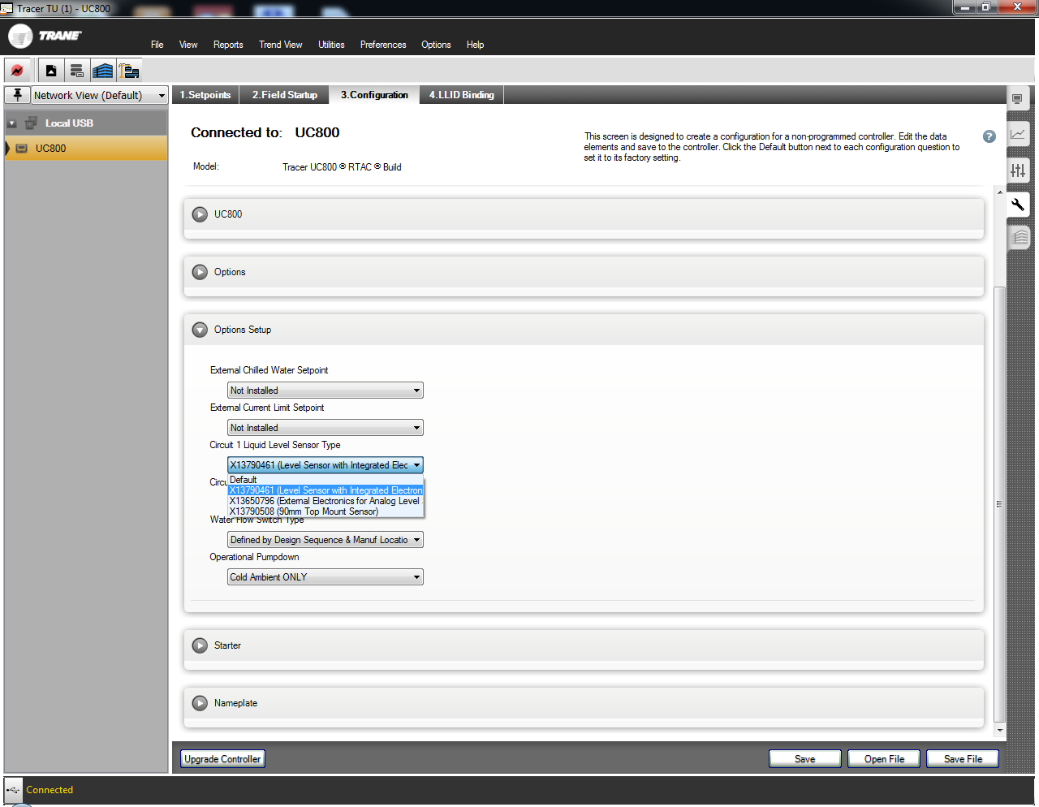

The UC800 RTAC firmware requires the level sensor to have llid firmware version 3 or greater

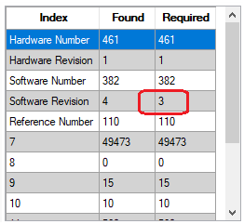

If not, the following error message will be displayed when attempting to bind the device

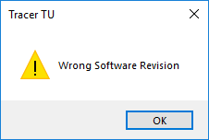

To correct this, the llid firmware must be upgraded.

Select upgrade llid…



When the confirmation dialog box appears, select the device with the magnet

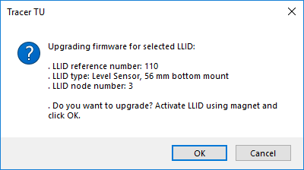

Press OK, download will proceed

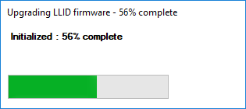

The following dialog box will appear if successful

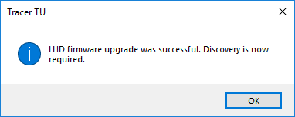

Rebuild binding view



The level sensor will have a status of red X



Select the device and Unbind it



Reselect the device and bind it again



The status should now be bound

