Product: All Terminal Products

Subject: Fire Alarm Shutdown- UC400 or CSTI Control Option

Details:
NOTE: Trane does not offer a point to shutdown the fan.

Recommendation is to break the 24v power to the control board.
With UC400 or Symbio break J15-5 from the transformer.
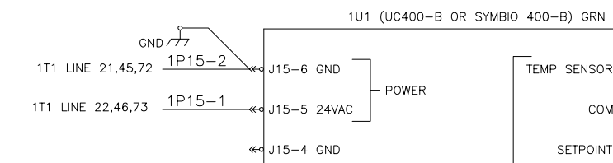

With CSTI break J12-1 from the transformer.
