- The dip switches on the back should be set to 1 on, rest of dip switches should be off to put the control into “single duct mode” (see page 14).
- Next you need to enter the “expert” code so you can change the parameters.
  - Press left button and right button simultaneously for >3 seconds
  - Release both buttons
  - press the left button for >3 seconds (Note the display will change slightly after this step, continue to step d)
  - then turn the rotary knob counterclockwise min. ½ rotation.
  - The display will now shows "Pxx".
- Set the following parameters:
  - P1 = Customer can set it how they like: 0 = heating only, 1 = cooling only, 3 = heating and cooling with automatic change over.
  - P7 = 1 This puts the in °F (I guess Canada would use “0” which is Celsius)
  - P47 = 1 This puts the control into 3 position mode. It will allow the unit to modulate accordingly (see graphs on page 12)
  - P63 = This is the damper minimum position, set to desired percentage.
  - P64 = This is the damper maximum position, set to desired percentage.
  - P65 = This is called “protection heating setpoint” but a better name would be frost protection. In cooling mode, if the temperature sensed is below this setpoint the unit will go into protection mode to keep the unit from freezing. Protection mode causes the damper to go full closed (more on that later).
  - P66 = This is called “protection cooling setpoint” but a better name would be overheating protection. In heating mode, if the temperature sensed is above this setpoint the unit will go into protection mode to keep the unit from overheating. Protection mode causes the damper to go full closed (more on that later).

PROTECTION MODE:
Protection mode ignores the minimum and maximum damper positions and forces the damper full closed. However, it is worth noting the control has two buttons on it.
- The left button allows you to:
  - exit the menu you are in
  - change between heating and cooling mode
- The right button allows you to:
  - Press ok to accept what you have selected
  - Force the unit into protection mode.
IF YOU ACCIDENTALLY HIT THE RIGHT BUTTON, IT WILL FORCE THE DAMPER FULL CLOSED. The button will still force the unit into protection mode even if you set parameters P65 and P66 to off. To tell if you are in protection mode, check the display. A small house shaped icon will appear in the lower left corner to tell you it is in protection mode. To exit the mode, hit the right button again.

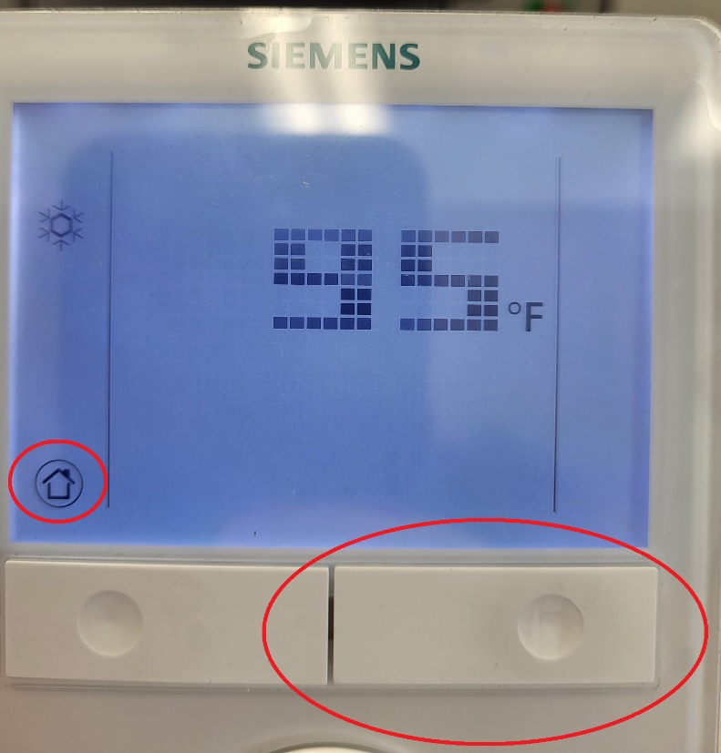

So to summarize, we don’t actually need to change anything to set the minimum damper position. We can use the Siemen’s actuator with the RDG400 and don’t need a separate min pot. Most of the above is set by the factory and the customer just needs to set P1, P63 and not accidentally hit the right button.

