**Factory Piping Packages**

**Test and balance**:

In today’s design, the PT ports are located on the supply side upstream of the shutoff valve and on the return side downstream of the autoflow valve. When measuring between the two ports, the differential pressure can be found. Given the placement of these components, the pressure drop across the coil and piping package will need to be known values to determine if the system flow is as expected. This information is provided for each unit and can be found in the TSA outputs and submittals.

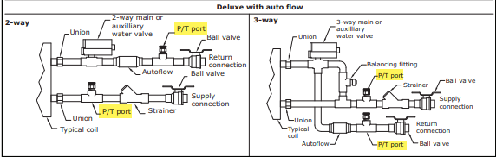

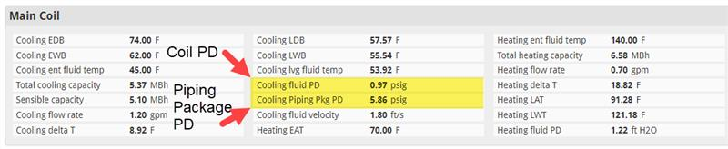

The autoflow valve that is used in today’s product is designed to maintain system flow within a $±10\%$ accuracy, given the system pressure is within the differential pressure ranges below.

Differential Operating Pressure:

* 2 – 80 PSID 0.5 – 5.0 GPM
* 3 – 80 PSID 5.5 – 9.0 GPM

To verify system flow rate, set the control valve to a fully open position (no bypass for 3-way piping packages). Next, measure the pressure drop across the given PT ports on the supply and return side. In the submittal or TSA output, find the calculated pressure drop values for the coil and piping package. With this information, plug into the equation (1) below:

1. [Measured PD] - [Coil PD] - [Piping Package PD] + [Autoflow PD] = Pressure Value1

Where,

[Autoflow PD] =

* 4.62 FT 0.5 – 5.0 GPM
* 6.93 FT 5.5 – 9.0 GPM

Given the pressure is within the published operating range of 2 – 80 psid for low flow and 3 – 80 psid for high flow, it is ensured by the autoflow valve supplier, that the system flow rate is set to the designed flow rate.

Example:

Technician A wants to verify the flow rate across each unit in a new building. There are a total of 10 new fan coils that are being tested and balanced. Technician A will use their own pressure temperature gauge to measure the differential across the two Trane provided PT ports in the piping package. The measured pressure differential was 9.83 psid. Technician A used the measured and calculated pressure drop values to determine if the flow rate was as designed.



[Measured PD] - [Coil PD] - [Piping Package PD] + [Autoflow PD] = Pressure Value1

[9.83 psi] - [0.97 psi] - [5.86 psi] + [4.62 ft * 0.433 psi/ft H20] = 5 psi

The differential pressure of 5 psi is within the published operating range of 2 – 80 psid for low flow rates, which verifies the units flow rate is within tolerance of $±10\%$.