Product: BCXE
Subject: Mixing Box - Actuator wiring detail and mixing box section

Details:
- The actuator is the same for LH and RH actuator access.
- LH/ RH is determined by facing the discharge or (supply air blowing into your face). The actuator linkage will be longer on that side.
NOTE: It can be changed in the field by loosening the clamps and sliding the shaft to the other side.

Actuator part number = Trane ACT00338 or Engineering X13611055030
WIRING DETAIL:
Wires at the actuator are: Black =common or hot, Red = common or hot, White = Open/ close (Based on actuator mounting), Green = Open/ close (Based on actuator mounting)
CSTI
Red = 24v hot from the actuator to the yellow wire on the harness (50262995)
Black = 24v common from the actuator to the blue wire from the harness (50262995)

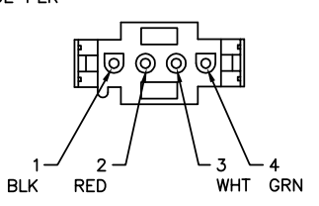

UC400/ Symbio
Red = 24v common from the actuator to the blue wire from the harness
Black = 24v hot from the actuator to the yellow wire from the harness

Mounting actuator
The factory bracket connects to the actuator and the damper edge. Self-tapping screws are used to connect actuator bracket to the damper section as shown.

Rotation of the actuator and linkage
Closed or open position are determined by the back or return air damper blades.
See examples also found in the IOM for size 12 to 72 and 90 to 120.
